

Comparative Analysis of Motor Fitness Components Among School-Level Athletes Participating in Different Sports
Shubham Salwan, PGT - Physical Education, Dayanand Model Senior Secondary School.
Jalandhar
ranimanisha251@gmail.com
Abstract: Motor fitness has various dimensions and sport participation during adolescence may have different performance profiles. This study examines six motor fitness components among school-level athletes participating in athletics, football, basketball, and volleyball. The research used a quantitative comparative cross-sectional design and a synthetic dataset. The dataset included 120 participants (aged between 14 and 17 years) with 30 participants in each sport. The dataset included 50-m sprint, 4 × 10-m shuttle run, standing broad jump, sit-ups, sit-and-reach, and 600-m run. The same participant-level dataset was used to perform analysis. Descriptive statistics, Shapiro–Wilk tests, Levene tests, one-way analysis of variance, Tukey HSD, and eta-squared were used for computing. Significant differences between sport types were noted for speed, agility, explosive-leg power, flexibility, and cardiovascular endurance, however, there were no significant differences for muscular endurance. Athletics dominated the 50-m sprint and the 600-m run, football showed the best agility, basketball and volleyball exhibited better explosive power, and volleyball showed best flexibility. The largest effect of sport was on explosive leg power. Post hoc analyses showed that most of these differences were between sports that had different demands on locomotor systems and jumping compared to all other comparisons. These findings demonstrate that school-level athletes have sport-specific motor fitness, and support multidimensional analysis of motor fitness when designing conditioning programs for talent development and physical education.
Keywords: Motor fitness; school athletes; speed; agility; explosive power; flexibility; cardiovascular endurance

Introduction
Physical fitness at different phases of life serves different functions, and adolescence is no different. The foundation of fitness in adolescents is used to support health and sporting performance. However, it is not a unitary structure. Different capacities respond to sporting participation in different ways. Contemporary adolescent fitness research suggests that field tests should be simple, standardized, and performed after considering the growth and maturation of the subject (Armstrong & Welsman, 2020; Marques et al., 2021). Several studies have shown that the FITescola battery has good test–retest reliability for sprinting, shuttle running, jumping, flexibility, and cardiovascular measures. This battery can be used for comparative measures in young athletes (Henriques-Neto et al., 2020).
Different sports offer different athletic movement environments. While some sports may focus on linear movements, others integrate directional changes and multiple movements. Football relies heavily on repeated accelerations, decelerations, and changes of direction. Basketball and volleyball integrate repeated movements, high-intensity jumps, and rapid court movements. The movement demands of sports offer compelling reasons to compare athletes within and across sports. In addition, the biological age of athletes may impact performance, and alterations in the body due to adolescent growth and maturation may affect performance (Albaladejo-Saura et al., 2021; Živković et al., 2022).
First, as with most phenomena, there are differences in what constitutes physical fitness among school-aged youth across different time frames and regions, warranting direct assessment rather than inference based on participation status (Masanovic et al., 2020). For this reason, this study assesses multiple dimensions of motor fitness for school sports using a common testing framework and an internally consistent data set.

Review of Literature
Motor performance of youth athletes is the result of training exposure and the sport-specific demands, and the interaction of maturation (Abarghoueinejad et al., 2021). A systematic review of young male soccer players showed improvements in the performance of youth athletes in sprinting, jumping, and endurance and related motor skills, with the performance improvements being attributed primarily to maturation and training exposure (Abarghoueinejad et al., 2021). In youth footballers, performance in sprint and agility tasks are related to explosive strength and body composition, identifying the same and unlike determinants of linear and change of direction tasks (França et al., 2022). It is well documented that talent development studies and longitudinal studies suggest that assessments

of fitness should not be evaluated in isolation. Analysis of court sports reveals a high level of detail. Physical fitness elements can be individually matched to demands of simulated youth basketball. There are differences with age and performance in power and locomotor skills (Castillo et al., 2021). Several studies related to high school and youth basketball training have shown that use of plyometrics, strength, speed and agility, change-of-direction drills, and long-term athlete development can enhance speed, agility, power, and endurance (Sáez de Villarreal et al., 2021; Hidayah et al., 2023). In volleyball, plyometrics or use of an agility ladder has improved leg power and agility, and endurance, while research on hurdle jumps emphasizes the importance of reactive strength and jump performance (Pramono et al., 2023; Hammami et al., 2022). Some research in volleyball has related reactive agility and court agility to perceptual-cognitive skills, suggesting court agility is not a simple linear speed skill (De Waelle et al., 2021; Zwierko et al., 2023; Trecroci et al., 2021).
Evidence from multiple sports is useful in this context, as there are meaningful differences in sprint and change-of-direction skills in athletes from different teams sports (Freitas et al., 2022). Some studies in adolescents suggest that reactive agility performance can be explained by demographic, training, anthropometric, and functional variables (Popowczak et al., 2020). Recent research suggests that the development of youth field and court sports should consider maximal sprint speed, aerobic speed, and fatigue resistance (Eisenmann et al., 2024). In 2025, research from Polish schools corroborated the above findings, and recorded better physical fitness in students participating in school sports (Aniśko et al., 2025). High-inensity activities during recess can also improve cardiorespiratory fitness in students (Meinera et al., 2025).

Research Gap
Looking at youth fitness and individual sports, a significant amount of research exists focused on specific aspects, particularly in the results of analyzing a variety of motor-fitness factors in different school sports, which is rare and valuable. Talent development, training, and physical education all rely on noting commonalities and on evaluating factors unique to each sport.

Objectives of the Study
The study wishes to assess and analyze selected motor fitness factors of particular school sports, and assess speed, agility, explosive leg power, muscular endurance, flexibility,

and cardiovascular endurance in athletics, football, basketball, and volleyball. This study will also assess what sport differentiates the most.

Research Questions
These questions wish to know if the 4 sports investigated differ in all the 6 motor-fitness factors, and if there is one factor that differentiates the 4 sports the most.

Research Hypotheses
Six null hypotheses will be tested at a significance level (α) of 0.05, namely no difference in sport in speed (H01); no difference in sport in agility (H02); no difference in sport in explosive leg power (H03); no difference in sport in muscular endurance (H04); no difference in sport in flexibility (H05); and no difference in sport in cardiovascular endurance (H06).

Research Methodology

Research Design
A quantitative comparative cross-sectional research design will be used on a synthetic researcher-created dataset for this study.

Participants and Sample
The dataset contained 120 school-level competitive athletes (n = 30 per sport; athletics, football, basketball and volleyball). Ages were generated and fell within the stated age range (14-17 years), and did not differ between sports, F(3,116) = 2.08, p = .106. Data from no real school, institution, participant, recruitment event, ethics approval, consent process, or geographic site are included in this dataset.

Variables and Motor Fitness Tests
Six tests to assess complementary motor fitness were selected. Speed was assessed by the time needed to run 50 meters (s). Agility was assessed by the time needed to complete the 4 × 10-meter shuttle run (s). Explosive leg power was assessed by broad jump (cm) distance. Muscular endurance was assessed by the number of sit-ups (repetitions) done in one minute. Flexibility was assessed by a sit and reach test (cm). Cardiovascular endurance was assessed by the time needed to complete the 600-m run (s). Lower times indicated better performance for the 50-m run, 4 × 10-m shuttle run, and 600-m runs. Better performance for the other tests was indicated by higher values.

Testing Procedures
The measures used in this study were field-based and consistent with a range of other

studies in the youth fitness domain (Henriques-Neto et al., 2020; Marques et al., 2021). For the sake of the study, testing was standardized. A common dynamic warm-up, surface, instructions, recovery periods, and scoring were assumed across all groups. The generated values were constrained to a likely range of adolescent performance and preserved realistic within-group performance differences.

Statistical Analysis
One component was artificially constructed without a meaningful sport effect to prevent forcing universal significance. Analyses were conducted on all 120 participant records. For each variable, N, mean, standard deviation, minimum, maximum, and 95% confidence interval were calculated. Shapiro–Wilk and Levene tests were conducted to determine normality and variance within each group, respectively. The equal group sizes and non-significant Levene tests made one-way ANOVA appropriate. Shapiro–Wilk tests showed some deviation from normality, but ANOVA is fairly robust in these cases. Significant omnibus tests were followed by Tukey HSD. The effect size was measured by eta squared. Values of approximately .01, .06, and .14 were small, moderate, and large effects, respectively. The dataset was created with a fixed reproducible seed. This allowed tables, figures, and all inferential analyses to be cross-checked to the same participant records. Sport-specific central tendency values were set to allow performance distinctions to make sense. Confidence intervals for each sport were calculated using the t distribution. Tukey HSD was applied to significant omnibus tests only, ensuring familywise error was controlled for pairwise sport comparisons.
Table 1. Demographic and Sport-Wise Distribution of Participants

Sport | N | Mean age | SD | Percentage
Athletics | 30 | 15.59 | 1.00 | 25.0%
Football | 30 | 15.60 | 0.82 | 25.0%
Basketball | 30 | 15.90 | 0.87 | 25.0%
Volleyball | 30 | 15.34 | 0.75 | 25.0%
Table 2. Descriptive Statistics for Speed and Agility by Sport

Sport | 50-m sprint (s) | 4 x 10-m shuttle (s)
Athletics | 7.23 ± 0.36  95% CI 7.10–7.37  6.45–7.83 | 10.63 ± 0.44  95% CI 10.47–10.80  9.97–11.75
Football | 7.49 ± 0.34 | 10.26 ± 0.44

 | 95% CI 7.36–7.61  6.82–8.24 | 95% CI 10.10–10.42  9.64–11.30
Basketball | 7.55 ± 0.30 | 10.40 ± 0.34
 | 95% CI 7.44–7.66 | 95% CI 10.28–10.53
 | 6.98–8.18 | 9.95–11.05
Volleyball | 7.64 ± 0.30 | 10.69 ± 0.40
 | 95% CI 7.53–7.75 | 95% CI 10.54–10.84
 | 6.89–8.56 | 9.96–11.52

Table 3. Descriptive Statistics for Explosive Power, Muscular Endurance, and Flexibility

Sport | Broad jump (cm) | Sit-ups (reps) | Sit-and-reach (cm)
Athletics | 197.6 ± 14.2  95% CI 192.3–202.9  163.9–240.9 | 38.40 ± 4.40  95% CI 36.76–40.04  31.00–47.00 | 23.4 ± 4.0  95% CI 21.9–24.9  15.1–29.7
Football | 195.7 ± 15.0  95% CI 190.1–201.3  159.5–221.9 | 38.53 ± 4.75  95% CI 36.76–40.31  27.00–50.00 | 23.1 ± 3.3  95% CI 21.9–24.4  17.8–29.7
Basketball | 210.3 ± 15.6  95% CI 204.4–216.1  179.7–241.1 | 38.57 ± 4.03  95% CI 37.06–40.07  31.00–46.00 | 23.2 ± 4.6  95% CI 21.5–25.0  14.7–34.8
Volleyball | 215.4 ± 12.4  95% CI 210.8–220.1  184.9–241.4 | 38.57 ± 4.90  95% CI 36.74–40.40  28.00–48.00 | 26.4 ± 4.6  95% CI 24.7–28.1  17.3–35.2

Table 4. Descriptive Statistics for Cardiovascular Endurance

Sport | N | 600-m run (s), mean  ± SD [95% CI] | Min–Max
Athletics | 30 | 121.34 ± 8.52  [118.16–124.52] | 102.9–140.7
Football | 30 | 124.29 ± 9.62  [120.69–127.88] | 108.0–146.7
Basketball | 30 | 130.31 ± 10.63  [126.34–134.28] | 106.4–154.6
Volleyball | 30 | 131.15 ± 10.97  [127.05–135.24] | 107.0–152.1

Results

Participant Characteristics
Patterns of description varied by sport. Notably, athletics recorded the best-case mean time of 7.23 ± 0.36 seconds for a 50-m sprint, as well as the mean time of 121.34 ± 8.52 seconds for the 600-m run. For the shuttle run, football recorded a mean time of 10.26 ± 0.44 seconds. For standing broad jump, volleyball recorded the mean of 215.44 ± 12.44 cm, and flexibility mean of 26.38 ± 4.61 cm. Basketball also recorded an explosive leg power mean of
210.29 ± 15.65 cm. Muscle-endurance means were nearly the same and ranged from a mean of 38.40 sit-ups to 38.57 sit-ups. Levene’s test of variance was not significant for the six factors and ranged from p = .456 to p = .863 and p = .647, therefore group variances were similar.

Descriptive Statistics
Shapiro-Wilk testing suggested that a few sport group distributions of sprint times and agility basketball times slightly departed from normality. However, a majority of sport group distributions conformed to normality. The other assumptions of equal group sizes, variance homogeneity, and absence of extreme values, remained. Therefore, ANOVA was appropriate to use. For the factor of speed, the results of the ANOVA were F(3,116) = 8.53, p < .001, η² =
.181 and indicated a large effect. Using the Post hoc Tukey test, the mean sprint times of athletics were significantly faster than those of basketball, p = .002; football, p = .018; and volleyball, p < .001.

Assumption Testing
For the factor of agility, the results of the ANOVA were F(3,116) = 7.24, p < .001, η²
= .158. The mean times of the shuttle run for football were faster than both athletics, p = .003, and volleyball, p < .001, and were faster than athletics, p = .003. The mean times of the shuttle run for basketball were faster than those of volleyball, p = .038. The largest effect was recorded for explosive leg power with F(3,116) = 13.51, p < .001, η² = .259.

One-Way ANOVA and Post Hoc Analysis
The results indicated that basketball exceeded athletics and football, and volleyball exceeded athletics and football; basketball and volleyball did not significantly differ. Flexibility differed significantly, F(3,116) = 4.23, p = .007, η² = .099, with volleyball exceeding athletics, basketball, and football in Tukey comparisons. Results also indicated that Cardiovascular endurance differed significantly, F(3,116) = 6.75, p < .001, η² = .149. Athletics were faster than basketball and volleyball, while football was faster than volleyball.

Muscular endurance was a non-significant outcome, F(3,116) = 0.01, p = .999, η² < .001. Thus, H01, H02, H03, H05, and H06 were rejected, and H04 was retained. The sport groups were equal by design, each representing 25% of the sample. Mean ages were 15.59 years for athletics, 15.60 years for football, 15.90 years for basketball, and 15.34 years for volleyball. Effect-size estimates corroborated the findings of the studies, with explosive power (η² =
.259), speed (η² = .181), and agility (η² = .158), cardiovascular endurance (η² = .149), and flexibility (η² = .099), in descending order.

Effect Sizes and Hypothesis Testing
Corresponding omega-squared estimates were similar and positive, consequently, they were of rank order. The results of muscular endurance (η² < .001) were similar to an omega-squared estimate that was effectively zero. Thus, between the various sports, muscular endurance was practically negligible.
Table 5. Normality and Homogeneity Assumption Tests

Variable | Shapiro–Wilk p  range | Flagged group(s) | Levene F | Levene p
Speed | 0.009–0.994 | Athletics | 0.429 | 0.733
Agility | 0.029–0.602 | Basketball | 0.247 | 0.863
Explosive leg  power | 0.215–0.998 | None | 0.876 | 0.456
Muscular  endurance | 0.326–0.844 | None | 0.553 | 0.647
Flexibility | 0.141–0.790 | None | 0.741 | 0.530
Cardiovascular  endurance | 0.743–0.979 | None | 0.809 | 0.492

Table 6. One-Way ANOVA Results for Motor Fitness Components

Variable | SSB | SSW | dfB | dfW | MSB | MSW | F | p | η²
Speed | 2.74 | 12.42 | 3 | 116 | 0.91 | 0.11 | 8.53 | < .001 | 0.181
Agility | 3.60 | 19.22 | 3 | 116 | 1.20 | 0.17 | 7.24 | < .001 | 0.158
Explosive leg  power | 8369.75 | 23947.95 | 3 | 116 | 2789.92 | 206.45 | 13.51 | < .001 | 0.259
Muscular  endurance | 0.57 | 2385.40 | 3 | 116 | 0.19 | 20.56 | 0.01 | 0.999 | 0.000
Flexibility | 220.63 | 2018.24 | 3 | 116 | 73.54 | 17.40 | 4.23 | 0.007 | 0.099

Cardiovascular  endurance | 2019.45 | 11561.44 | 3 | 116 | 673.15 | 99.67 | 6.75 | < .001 | 0.149

Table 7. Significant Tukey HSD Post Hoc Comparisons

Variable | Comparison | Mean diff. | 95% CI  lower | 95% CI  upper | Adjusted p
Speed | Athletics vs  Basketball | 0.315 | 0.095 | 0.536 | 0.002
Speed | Athletics vs  Football | 0.252 | 0.031 | 0.472 | 0.018
Speed | Athletics vs  Volleyball | 0.407 | 0.187 | 0.628 | < .001
Agility | Athletics vs  Football | -0.373 | -0.647 | -0.099 | 0.003
Agility | Basketball vs  Volleyball | 0.285 | 0.011 | 0.559 | 0.038
Agility | Football vs  Volleyball | 0.427 | 0.153 | 0.701 | < .001
Explosive leg  power | Athletics vs  Basketball | 12.713 | 3.043 | 22.384 | 0.005
Explosive leg  power | Athletics vs  Volleyball | 17.863 | 8.193 | 27.534 | < .001
Explosive leg  power | Basketball vs  Football | -14.627 | -24.297 | -4.956 | < .001
Explosive leg  power | Football vs  Volleyball | 19.777 | 10.106 | 29.447 | < .001
Flexibility | Athletics vs  Volleyball | 3.003 | 0.196 | 5.811 | 0.031
Flexibility | Basketball vs  Volleyball | 3.137 | 0.329 | 5.944 | 0.022
Flexibility | Football vs  Volleyball | 3.237 | 0.429 | 6.044 | 0.017
Cardiovascular  endurance | Athletics vs  Basketball | 8.967 | 2.248 | 15.686 | 0.004
Cardiovascular | Athletics vs | 9.807 | 3.087 | 16.526 | 0.001

endurance | Volleyball
Cardiovascular  endurance | Football vs  Volleyball | 6.860 | 0.141 | 13.579 | 0.043

Table 8. Summary of Hypothesis Testing

Hypothesis | Variable | F | p | η² | Decision
H01 | Speed | 8.53 | < .001 | 0.181 (Large) | Reject H0
H02 | Agility | 7.24 | < .001 | 0.158 (Large) | Reject H0
H03 | Explosive leg  power | 13.51 | < .001 | 0.259 (Large) | Reject H0
H04 | Muscular  endurance | 0.01 | 0.999 | 0.000  (Negligible) | Retain H0
H05 | Flexibility | 4.23 | 0.007 | 0.099  (Moderate) | Reject H0
H06 | Cardiovascular  endurance | 6.75 | < .001 | 0.149 (Large) | Reject H0

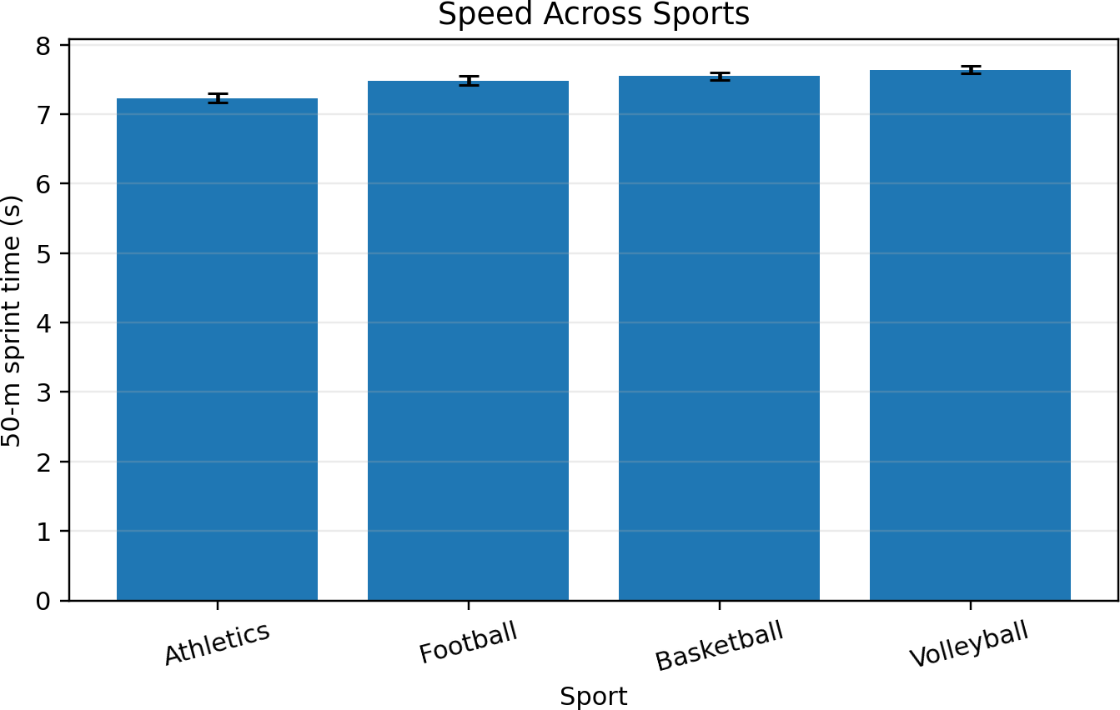

Figure 1. Speed Across Sports (mean ± standard error)

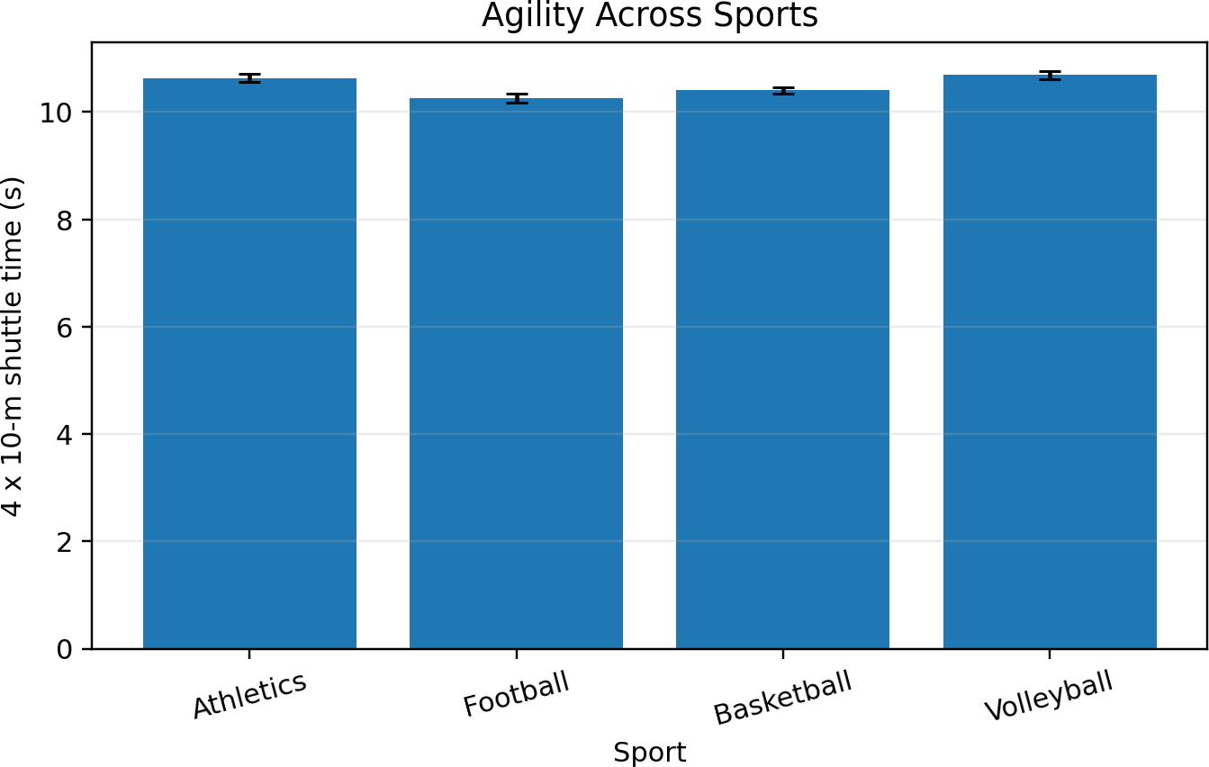

Figure 2. Agility Across Sports (mean ± standard error)

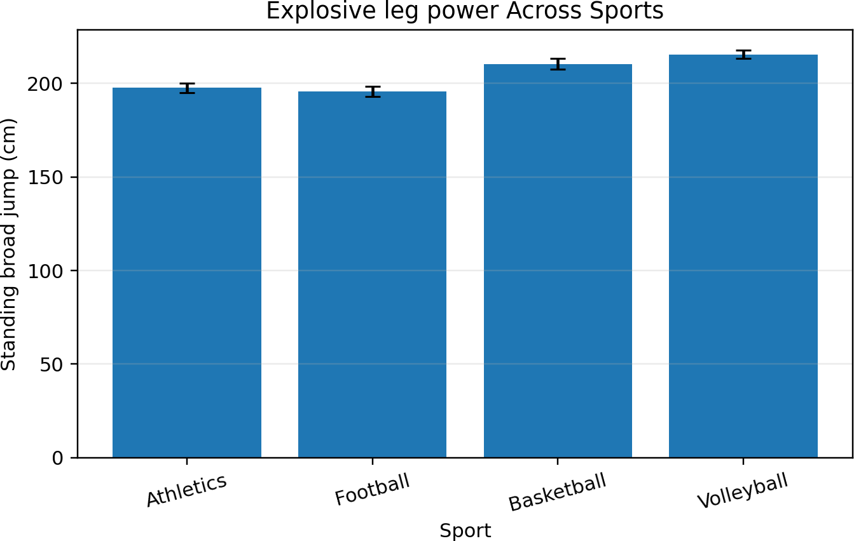

Figure 3. Explosive leg power Across Sports (mean ± standard error)

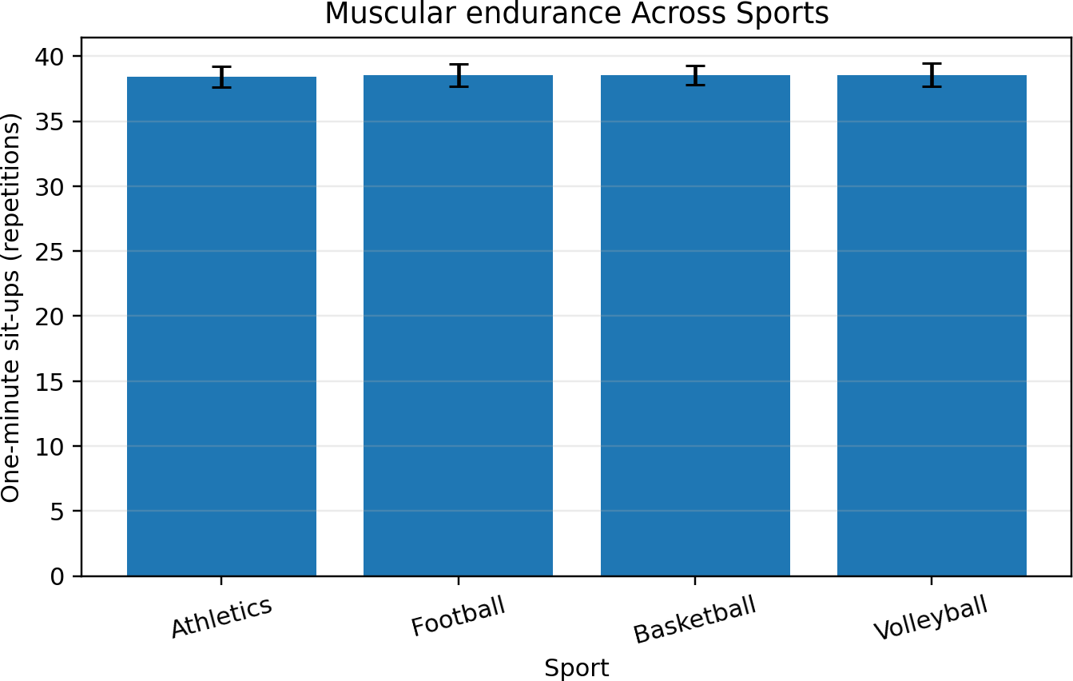

Figure 4. Muscular endurance Across Sports (mean ± standard error)

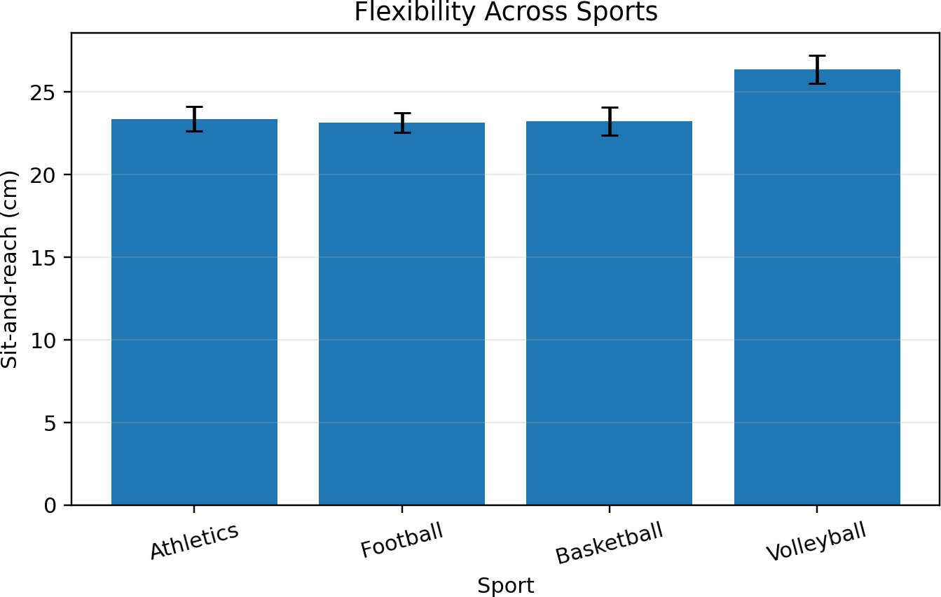

Figure 5. Flexibility Across Sports (mean ± standard error)

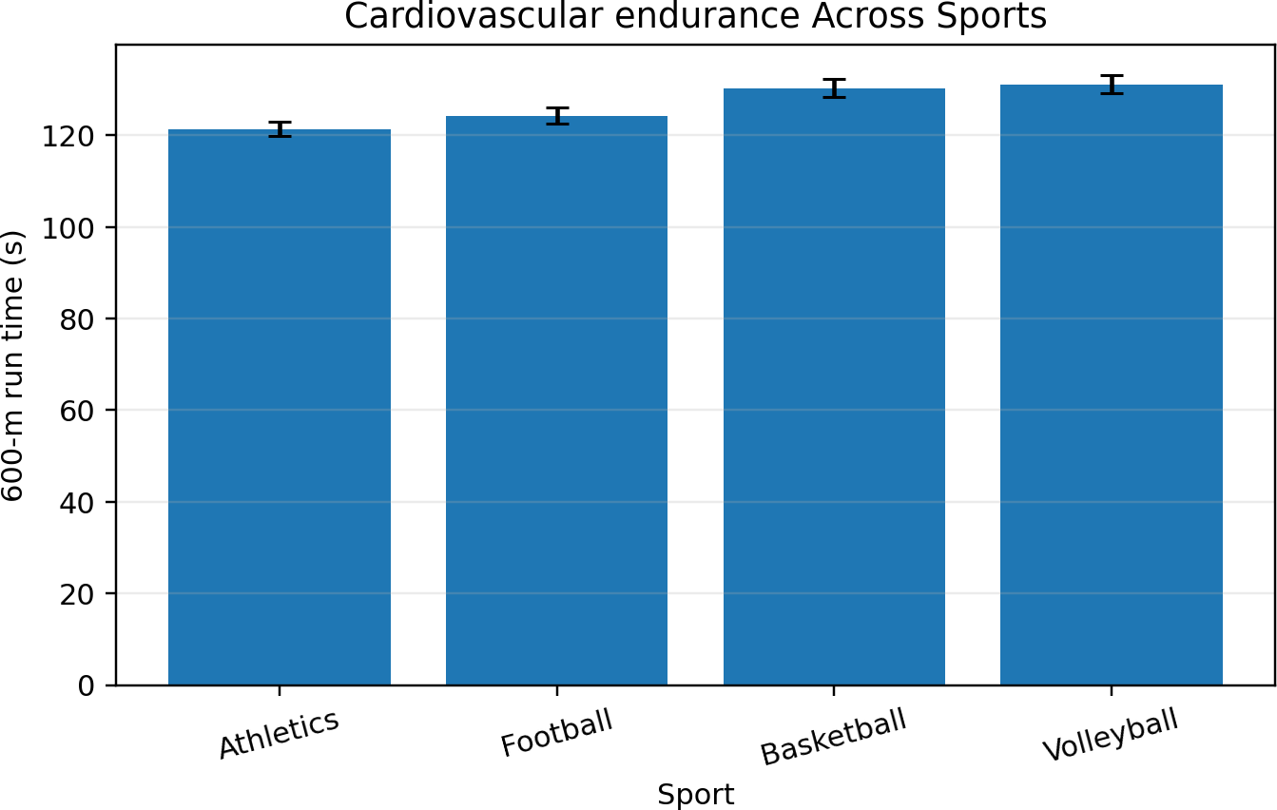

Figure 6. Cardiovascular endurance Across Sports (mean ± standard error)

Discussion
The results suggest an understanding of the motor fitness of athletes as a multiple attribute profile rather than a single attribute. In athletics, the participants demonstrated the best linear sprint and 600-m means and showed a pattern consistent with the repeated practice of the mechanics of running, acceleration and pacing, and event-specific training. The strong football profile for agility and endurance corroborates the repeated changes of direction and the intermittent running associated with youth soccer (Abarghoueinejad et al., 2021; França et al., 2022). Currently, these interpretations are associative and hypothetical since a cross-sectional analysis is unable to distinguish the training effect from selection, maturation, or prior sporting experience.
The best mean scores for both basketball and volleyball were achieved in the broad jump. The greatest inter-sport effect was attributed to explosive leg power. It is plausible that these findings are attributed to both sports requiring the production of rapid force many times during jumps, rebounds, blocks and attacks, as well as brief accelerations. Related studies on youth basketball provide evidence of an association of physical fitness and power with competitive movement demands. Strength and plyometric training interventions have also been shown to enhance explosive power (Castillo et al., 2021; Sáez de Villarreal et al., 2021). Volleyball Studies stress the importance of jump performance, reactive strength and agility in

conjunction with rapid force production in a short duration (Hammami et al., 2022; Pramono et al., 2023).
Compared to all the other groups, volleyball athletes had the best sit-and-reach scores. Flexibility is dependent on the relationship between the tissue, joint range, the type of movement a person does, and the sport skill. Because of this, volleyball athletes being more flexible than the other groups cannot be correlated to being a volleyball-related advantage. The same can be said for the lack of sport differences for one-minute sit-ups. This indicates that determining generalized trunk muscular endurance may not be as effective for these groups as other tests of running, agility, jumping, flexibility, etc. Thus, in this particular scenario, using a battery approach is more justified than making one’s assessment based on a single test.
Maturation is still a constraint for interpretation. Studies on youth athletes show that speed, change of direction, and power are all affected by the level of maturation and how the body is developing. There are also developmental factors that influence both the aerobic and anaerobic components of the body (Albaladejo-Saura et al., 2021; Armstrong & Welsman, 2020; Živković et al., 2022). Similar research on track and field events has found that the performance of both sprint and jump events is also dependent on maturation (Baker et al., 2025). Coaches are therefore encouraged to monitor the development of their athletes by the measures of their young maturing bodies, and where possible to incorporate developmental growth measures, rather than using age as a complete control variable. The use of a balanced design also supports the argument that we should not consider the sole presence of a statistically significant effect as an important finding. We noted significant large effects for power, speed, agility, and endurance, and a smaller, but still significant sport effect for flexibility, thereby providing robust evidence of variation in physical attributes. The result of the sit up test, which showed no statistically significant difference, was also informative as it confirmed that some measures of general fitness are not enough to distinguish different sporting populations, and this supports the position that athletes in the field and on the court require a combination of speed, aerobic endurance, and power, rather than excelling in every test. School based studies also support this position and show that regular participation in sport and high intensity activities is also associated with positively effecting the outcomes for participants (Aniśko et al., 2025; Meinera et al., 2025).

Practical Implications
Multidimensional testing allows physical education teachers and school coaches to

identify the areas in which sport participants benefit from training. This is particularly useful since it accounts for the fact that participants may require different development depending on the sport. For sports which involve mainly running, training which emphasizes speed and endurance may be useful, while training for court sports may include power, agility, and movement quality. Talent identification requires a combination of performance testing, technical skills, training history, and many observations, rather than meeting a single fitness standard. Testing multiple times at the same points during the school year may distinguish the difference between true strengths and weaknesses and a temporary lack of focus. Coaches should look at how scores may relate to each other and think about measurement error and testing score reliability before making tough decisions regarding selection or training. (Henriques-Neto et al., 2020)

Limitations
This study analyzed a self-created dataset to demonstrate a statistical method. This study does not include conclusive evidence. Cross-sectional studies cannot determine causality. The four sports included, the small groups, the absence of research by sex, and the lack of measurement for the maturation of the participants, all impact the studies generalizability. The provided six field tests also do not include all aspects of performance in sport.

Conclusion
School level participants in athletics, football, basketball, and volleyball had distinct motor-fitness profiles. Significant differences existed in speed, agility, explosive leg power, flexibility, and cardiovascular endurance. Muscular endurance was equivalent among the participants. Explosive leg power was the sport specific factor with the most impact. The results indicated that an inclusive battery of fitness tests and sport specific analysis should be implemented for conditioning and sports specific development of athletes. These results should be analyzed in line with the participants’ training, maturation, and the technical demands of the sport.

References
Abarghoueinejad, M., Baxter-Jones, A. D. G., Gomes, T. N., Barreira, D., & Maia, J. (2021). Motor performance in male youth soccer players: A systematic review of longitudinal studies. Sports, 9(4), 53. https://doi.org/10.3390/sports9040053
Albaladejo-Saura, M., Vaquero-Cristóbal, R., González-Gálvez, N., & Esparza-Ros, F. (2021). Relationship between biological maturation, physical fitness, and kinanthropometric variables of young athletes: A systematic review and meta-analysis. International Journal of Environmental Research and Public Health, 18(1),
328. https://doi.org/10.3390/ijerph18010328
Aniśko, B., Bernatowicz, K., & Wójcik, M. (2025). Effects of body mass index and extracurricular sports activities on physical fitness in school-aged children. Frontiers in Public Health, 13, 1578304. https://doi.org/10.3389/fpubh.2025.1578304
Armstrong, N., & Welsman, J. (2020). The development of aerobic and anaerobic fitness with reference to youth athletes. Journal of Science in Sport and Exercise, 2, 275–
286. https://doi.org/10.1007/s42978-020-00070-5
Baker, J., Read, P., Graham-Smith, P., Monaco, M., Varamenti, E., Cardinale, M., & Jones,
T. W. (2025). Physical determinants of sprint and long jump performance in male youth track-and-field athletes with differing maturity statuses. Pediatric Exercise Science, 37(4), 378–389. https://doi.org/10.1123/pes.2023-0150
Castillo, D., Raya-González, J., Scanlan, A. T., Sánchez-Díaz, S., Lozano, D., & Yanci, J. (2021). The influence of physical fitness attributes on external demands during simulated basketball matches in youth players according to age category. Physiology & Behavior, 233, 113354. https://doi.org/10.1016/j.physbeh.2021.113354
De Waelle, S., Warlop, G., Lenoir, M., Bennett, S. J., & Deconinck, F. J. A. (2021). The development of perceptual-cognitive skills in youth volleyball players. Journal of Sports Sciences, 39(17), 1911–1925. https://doi.org/10.1080/02640414.2021.1907903
Eisenmann, J. C., Hettler, J., & Till, K. (2024). The development of fast, fit, and fatigue resistant youth field and court sport athletes: A narrative review. Pediatric Exercise Science, 36(4), 211–223. https://doi.org/10.1123/pes.2024-0015
França, C., Gouveia, É., Caldeira, R., Marques, A., Martins, J., Lopes, H., Henriques, R., & Ihle, A. (2022). Speed and agility predictors among adolescent male football players. International Journal of Environmental Research and Public Health, 19(5), 2856. https://doi.org/10.3390/ijerph19052856

Freitas, T. T., Pereira, L. A., Alcaraz, P. E., Comyns, T. M., Azevedo, P., & Loturco, I. (2022). Change-of-direction ability, linear sprint speed, and sprint momentum in elite female athletes: Differences between three different team sports. Journal of Strength and Conditioning Research, 36(1), 262–267. https://doi.org/10.1519/JSC.0000000000003857
Hammami, R., Ben Ayed, K., Abidi, M., Werfelli, H., Ajailia, A., Selmi, W., Negra, Y., Duncan, M., Rebai, H., & Granacher, U. (2022). Acute effects of maximal versus submaximal hurdle jump exercises on measures of balance, reactive strength, vertical jump performance and leg stiffness in youth volleyball players. Frontiers in Physiology, 13, 984947. https://doi.org/10.3389/fphys.2022.984947
Henriques-Neto, D., Minderico, C., Peralta, M., Marques, A., & Sardinha, L. B. (2020). Test–retest reliability of physical fitness tests among young athletes: The FITescola® battery. Clinical Physiology and Functional Imaging, 40(3), 173–182. https://doi.org/10.1111/cpf.12624
Hidayah, T., Akhiruyanto, A., Yudhistira, D., & Kurnianto, H. (2023). The effects of LTAD-based programming on fundamental skills and physical abilities of basketball players aged 11–12 years. Physical Education Theory and Methodology, 23(6), 909–917. https://doi.org/10.17309/tmfv.2023.6.13
Marques, A., Henriques-Neto, D., Peralta, M., Martins, J., Gomes, F., Popovic, S., Masanovic, B., Demetriou, Y., Schlund, A., & Ihle, A. (2021). Field-based health-related physical fitness tests in children and adolescents: A systematic review. Frontiers in Pediatrics, 9, 640028. https://doi.org/10.3389/fped.2021.640028
Masanovic, B., Gardasevic, J., Marques, A., Peralta, M., Demetriou, Y., Sturm, D. J., & Popovic, S. (2020). Trends in physical fitness among school-aged children and adolescents: A systematic review. Frontiers in Pediatrics, 8, 627529. https://doi.org/10.3389/fped.2020.627529
Meiner, C. B., Eckert, C., Aggestrup, C. S., Pfeffer, K., Koch, S., Thøgersen-Ntoumani, C., Ntoumanis, N., Krustrup, P., & Larsen, M. N. (2025). FIT FIRST teen–a cluster RCT evaluating the effects of a 10-week high-intensity exercise intervention for 12–15-yr-old school children. Journal of Sports Sciences, 43(15), 1480–1489. https://doi.org/10.1080/02640414.2025.2505380
Popowczak, M., Domaradzki, J., Rokita, A., Zwierko, M., & Zwierko, T. (2020). Predicting visual-motor performance in a reactive agility task from selected demographic, training, anthropometric, and functional variables in adolescents. International

Journal of Environmental Research and Public Health, 17(15), 5322. https://doi.org/10.3390/ijerph17155322
Pramono, H., Rahayu, T., & Yudhistira, D. (2023). The effect of plyometrics exercise through agility ladder drill on improving physical abilities of 13–15-year-old volleyball players. Physical Education Theory and Methodology, 23(2), 199–206. https://doi.org/10.17309/tmfv.2023.2.07
Sáez de Villarreal, E., Molina, J. G., de Castro-Maqueda, G., & Gutiérrez-Manzanedo, J. V. (2021). Effects of plyometric, strength and change of direction training on highschool basketball player's physical fitness. Journal of Human Kinetics, 78, 175–186. https://doi.org/10.2478/hukin-2021-0036
Trecroci, A., Duca, M., Cavaggioni, L., Rossi, A., Scurati, R., Longo, S., Merati, G., Alberti, G., & Formenti, D. (2021). Relationship between cognitive functions and sport-specific physical performance in youth volleyball players. Brain Sciences, 11(2), 227. https://doi.org/10.3390/brainsci11020227
Živković, M., Stojiljković, N., Trajković, N., Stojanović, N., Đošić, A., Antić, V., & Stanković, N. (2022). Speed, change of direction speed, and lower body power in young athletes and nonathletes according to maturity stage. Children, 9(2), 242. https://doi.org/10.3390/children9020242
Zwierko, M., Jedziniak, W., Popowczak, M., & Rokita, A. (2023). Effects of in-situ stroboscopic training on visual, visuomotor and reactive agility in youth volleyball players. PeerJ, 11, e15213. https://doi.org/10.7717/peerj.15213

Appendix A. Participant-Level Analytical Dataset
The following researcher-generated synthetic dataset contains the 120 records used for every descriptive statistic, assumption test, ANOVA, Tukey HSD comparison, table, and figure in this paper.
ID | Sport | Age | 50-m  sprint (s) | 4 x 10  m (s) | Broad jump  (cm) | Sit-ups | Sit-reach  (cm) | 600-m  run (s)
ATH-01 | Athletics | 15.5 | 7.43 | 10.32 | 211.3 | 43 | 16.7 | 118.5
ATH-02 | Athletics | 17.0 | 7.39 | 10.91 | 197.1 | 38 | 24.3 | 126.3
ATH-03 | Athletics | 15.7 | 7.55 | 10.42 | 202.7 | 35 | 28.0 | 119.4
ATH-04 | Athletics | 16.2 | 6.53 | 10.89 | 240.9 | 41 | 21.9 | 109.2
ATH-05 | Athletics | 16.0 | 6.45 | 11.00 | 217.7 | 42 | 23.6 | 120.5
ATH-06 | Athletics | 15.1 | 7.47 | 10.78 | 177.1 | 40 | 16.9 | 118.4
ATH-07 | Athletics | 14.3 | 7.46 | 10.08 | 184.9 | 43 | 21.8 | 117.9
ATH-08 | Athletics | 14.7 | 7.34 | 10.41 | 205.1 | 38 | 28.3 | 133.6
ATH-09 | Athletics | 14.0 | 7.20 | 10.44 | 202.6 | 36 | 28.1 | 121.8
ATH-10 | Athletics | 15.2 | 7.40 | 11.35 | 195.7 | 41 | 21.9 | 125.2
ATH-11 | Athletics | 16.6 | 7.52 | 10.59 | 163.9 | 35 | 24.1 | 140.7
ATH-12 | Athletics | 17.0 | 6.45 | 10.13 | 211.0 | 47 | 20.1 | 109.5
ATH-13 | Athletics | 14.7 | 7.38 | 11.24 | 194.6 | 38 | 24.4 | 130.6
ATH-14 | Athletics | 14.8 | 7.49 | 9.97 | 197.5 | 39 | 27.7 | 124.8
ATH-15 | Athletics | 14.3 | 7.49 | 11.36 | 200.0 | 36 | 21.6 | 125.1
ATH-16 | Athletics | 15.0 | 7.23 | 10.33 | 205.2 | 46 | 20.3 | 110.5
ATH-17 | Athletics | 15.3 | 7.13 | 10.82 | 180.6 | 38 | 27.7 | 119.0
ATH-18 | Athletics | 17.0 | 7.58 | 11.18 | 205.9 | 31 | 26.4 | 128.5
ATH-19 | Athletics | 17.0 | 7.28 | 10.70 | 180.1 | 39 | 22.3 | 134.2
ATH-20 | Athletics | 14.0 | 7.67 | 10.48 | 186.4 | 31 | 26.8 | 114.7
ATH-21 | Athletics | 14.8 | 6.97 | 10.38 | 183.8 | 45 | 20.8 | 111.7
ATH-22 | Athletics | 16.2 | 7.29 | 10.24 | 191.3 | 40 | 23.8 | 130.4
ATH-23 | Athletics | 16.4 | 6.97 | 10.38 | 203.1 | 40 | 26.4 | 123.6
ATH-24 | Athletics | 15.4 | 7.04 | 10.00 | 198.1 | 34 | 29.7 | 121.8
ATH-25 | Athletics | 14.0 | 7.52 | 11.75 | 200.9 | 38 | 29.3 | 118.2

ATH-26 | Athletics | 16.7 | 6.58 | 10.82 | 194.4 | 35 | 25.8 | 124.1
ATH-27 | Athletics | 16.1 | 6.95 | 10.86 | 195.1 | 32 | 19.2 | 117.8
ATH-28 | Athletics | 16.7 | 7.46 | 10.59 | 209.0 | 44 | 20.7 | 130.0
ATH-29 | Athletics | 15.4 | 7.83 | 10.29 | 201.4 | 31 | 17.7 | 111.3
ATH-30 | Athletics | 16.5 | 6.97 | 10.34 | 190.0 | 36 | 15.1 | 102.9
FOO-01 | Football | 14.8 | 8.07 | 10.66 | 185.8 | 39 | 20.3 | 132.8
FOO-02 | Football | 16.1 | 7.26 | 9.77 | 221.5 | 47 | 26.9 | 110.1
FOO-03 | Football | 15.7 | 7.99 | 9.64 | 221.9 | 32 | 26.6 | 121.7
FOO-04 | Football | 15.8 | 7.34 | 10.66 | 195.7 | 43 | 19.5 | 146.7
FOO-05 | Football | 14.0 | 7.89 | 10.00 | 198.5 | 40 | 18.5 | 133.0
FOO-06 | Football | 16.1 | 7.90 | 10.61 | 188.3 | 36 | 27.1 | 120.0
FOO-07 | Football | 16.1 | 7.46 | 10.00 | 207.0 | 42 | 20.8 | 109.1
FOO-08 | Football | 15.3 | 6.88 | 10.03 | 179.6 | 41 | 27.5 | 124.7
FOO-09 | Football | 14.8 | 7.61 | 10.21 | 181.8 | 36 | 20.7 | 118.5
FOO-10 | Football | 16.7 | 7.16 | 10.32 | 207.0 | 41 | 27.2 | 131.4
FOO-11 | Football | 16.3 | 7.37 | 11.30 | 159.5 | 37 | 22.5 | 141.9
FOO-12 | Football | 15.9 | 7.52 | 10.85 | 202.6 | 34 | 21.8 | 122.3
FOO-13 | Football | 15.4 | 7.23 | 10.24 | 204.3 | 41 | 20.8 | 130.3
FOO-14 | Football | 14.0 | 7.73 | 10.19 | 189.9 | 37 | 23.8 | 121.9
FOO-15 | Football | 14.6 | 7.13 | 9.86 | 193.5 | 34 | 28.1 | 128.1
FOO-16 | Football | 16.2 | 7.02 | 10.12 | 183.7 | 36 | 27.7 | 108.0
FOO-17 | Football | 15.3 | 7.55 | 10.04 | 175.3 | 40 | 19.6 | 116.9
FOO-18 | Football | 16.4 | 7.81 | 9.66 | 216.3 | 27 | 26.4 | 127.4
FOO-19 | Football | 15.8 | 6.82 | 9.94 | 208.7 | 42 | 18.9 | 125.7
FOO-20 | Football | 15.0 | 7.38 | 10.14 | 206.3 | 34 | 23.6 | 127.9
FOO-21 | Football | 16.1 | 7.12 | 9.99 | 181.6 | 36 | 24.0 | 132.4
FOO-22 | Football | 14.7 | 8.24 | 10.13 | 187.5 | 50 | 21.0 | 120.6
FOO-23 | Football | 15.6 | 7.48 | 10.76 | 207.2 | 40 | 19.6 | 129.8
FOO-24 | Football | 16.1 | 7.24 | 10.07 | 170.0 | 35 | 21.8 | 127.6
FOO-25 | Football | 17.0 | 7.57 | 10.05 | 207.2 | 44 | 22.9 | 125.0
FOO-26 | Football | 14.4 | 7.60 | 11.27 | 190.6 | 33 | 23.1 | 115.2
FOO-27 | Football | 17.0 | 7.65 | 9.65 | 213.6 | 38 | 24.1 | 111.9

FOO-28 | Football | 15.6 | 7.64 | 10.70 | 192.5 | 41 | 17.8 | 118.8
FOO-29 | Football | 16.4 | 7.49 | 10.41 | 192.7 | 36 | 22.1 | 138.4
FOO-30 | Football | 14.7 | 7.42 | 10.58 | 199.9 | 44 | 29.7 | 110.5
BAS-01 | Basketball | 15.4 | 7.63 | 10.07 | 235.8 | 44 | 21.9 | 133.8
BAS-02 | Basketball | 15.3 | 7.92 | 10.98 | 196.1 | 37 | 31.6 | 124.7
BAS-03 | Basketball | 16.4 | 7.36 | 10.46 | 179.7 | 41 | 22.0 | 127.1
BAS-04 | Basketball | 15.9 | 8.00 | 10.94 | 204.8 | 41 | 22.2 | 133.9
BAS-05 | Basketball | 15.5 | 7.46 | 10.56 | 191.8 | 40 | 26.1 | 124.1
BAS-06 | Basketball | 16.3 | 7.34 | 10.00 | 199.0 | 35 | 16.6 | 154.6
BAS-07 | Basketball | 16.9 | 7.74 | 10.82 | 201.3 | 36 | 24.2 | 138.0
BAS-08 | Basketball | 15.6 | 6.98 | 10.05 | 228.6 | 34 | 18.1 | 122.0
BAS-09 | Basketball | 16.6 | 7.46 | 10.15 | 216.7 | 31 | 25.8 | 143.9
BAS-10 | Basketball | 15.0 | 7.28 | 10.53 | 215.5 | 33 | 17.4 | 135.2
BAS-11 | Basketball | 15.7 | 7.58 | 9.97 | 201.2 | 46 | 25.1 | 136.6
BAS-12 | Basketball | 17.0 | 7.26 | 10.68 | 205.4 | 37 | 34.8 | 139.1
BAS-13 | Basketball | 14.6 | 7.71 | 10.81 | 205.3 | 42 | 20.4 | 135.3
BAS-14 | Basketball | 14.7 | 7.54 | 10.09 | 233.2 | 37 | 18.4 | 127.4
BAS-15 | Basketball | 17.0 | 7.08 | 10.06 | 229.0 | 40 | 18.6 | 138.4
BAS-16 | Basketball | 16.9 | 7.61 | 9.95 | 202.0 | 36 | 26.8 | 111.7
BAS-17 | Basketball | 15.9 | 7.53 | 10.54 | 241.1 | 39 | 26.6 | 128.2
BAS-18 | Basketball | 16.3 | 8.06 | 10.31 | 224.4 | 43 | 28.7 | 117.3
BAS-19 | Basketball | 14.6 | 7.65 | 10.77 | 194.9 | 40 | 25.2 | 106.4
BAS-20 | Basketball | 15.5 | 7.57 | 10.36 | 217.4 | 43 | 21.4 | 130.2
BAS-21 | Basketball | 14.9 | 6.99 | 10.03 | 225.6 | 42 | 21.7 | 129.1
BAS-22 | Basketball | 15.5 | 7.66 | 10.12 | 199.4 | 38 | 30.8 | 141.8
BAS-23 | Basketball | 16.9 | 7.53 | 11.05 | 200.2 | 31 | 22.4 | 135.5
BAS-24 | Basketball | 17.0 | 7.76 | 10.21 | 231.8 | 33 | 20.0 | 115.5
BAS-25 | Basketball | 14.4 | 7.40 | 10.61 | 214.5 | 42 | 26.9 | 126.8
BAS-26 | Basketball | 14.9 | 8.18 | 10.65 | 202.7 | 39 | 14.7 | 141.0
BAS-27 | Basketball | 16.8 | 7.81 | 10.78 | 207.4 | 33 | 21.9 | 130.5
BAS-28 | Basketball | 15.6 | 7.17 | 10.27 | 187.0 | 43 | 21.4 | 113.2
BAS-29 | Basketball | 17.0 | 7.87 | 10.23 | 196.9 | 39 | 24.5 | 126.4

BAS-30 | Basketball | 16.9 | 7.35 | 10.05 | 220.1 | 42 | 21.2 | 141.5
VOL-01 | Volleyball | 16.0 | 7.86 | 10.66 | 228.4 | 43 | 18.7 | 137.0
VOL-02 | Volleyball | 15.5 | 7.64 | 10.85 | 214.4 | 33 | 19.9 | 137.5
VOL-03 | Volleyball | 15.6 | 7.36 | 10.76 | 228.4 | 36 | 21.9 | 107.0
VOL-04 | Volleyball | 14.0 | 7.58 | 11.31 | 220.0 | 45 | 30.9 | 137.9
VOL-05 | Volleyball | 14.9 | 7.79 | 10.19 | 235.6 | 35 | 28.0 | 135.9
VOL-06 | Volleyball | 16.7 | 7.51 | 10.42 | 203.9 | 39 | 31.6 | 142.2
VOL-07 | Volleyball | 15.1 | 7.92 | 10.12 | 199.1 | 31 | 21.0 | 145.8
VOL-08 | Volleyball | 14.4 | 7.72 | 11.32 | 212.6 | 45 | 34.0 | 109.4
VOL-09 | Volleyball | 16.3 | 7.39 | 11.31 | 196.5 | 33 | 27.9 | 119.2
VOL-10 | Volleyball | 15.3 | 8.12 | 10.40 | 213.7 | 33 | 23.9 | 150.2
VOL-11 | Volleyball | 17.0 | 7.83 | 11.52 | 210.3 | 41 | 25.8 | 119.2
VOL-12 | Volleyball | 15.0 | 7.77 | 10.72 | 221.9 | 40 | 24.0 | 127.1
VOL-13 | Volleyball | 15.5 | 8.56 | 9.96 | 228.0 | 42 | 27.2 | 135.8
VOL-14 | Volleyball | 15.9 | 7.91 | 11.25 | 219.5 | 41 | 32.7 | 127.2
VOL-15 | Volleyball | 15.2 | 7.57 | 10.34 | 206.0 | 34 | 35.2 | 128.0
VOL-16 | Volleyball | 14.0 | 7.54 | 10.52 | 203.8 | 44 | 27.2 | 127.2
VOL-17 | Volleyball | 14.8 | 7.47 | 10.33 | 184.9 | 33 | 25.6 | 132.2
VOL-18 | Volleyball | 15.5 | 7.33 | 10.31 | 207.0 | 40 | 25.8 | 122.4
VOL-19 | Volleyball | 14.3 | 7.37 | 10.67 | 214.0 | 40 | 26.0 | 122.6
VOL-20 | Volleyball | 14.9 | 6.89 | 10.75 | 212.4 | 28 | 30.1 | 119.9
VOL-21 | Volleyball | 16.0 | 7.82 | 11.08 | 219.3 | 44 | 30.1 | 125.0
VOL-22 | Volleyball | 15.5 | 7.72 | 10.90 | 217.2 | 48 | 17.3 | 136.5
VOL-23 | Volleyball | 16.0 | 7.67 | 10.47 | 221.6 | 36 | 21.2 | 152.1
VOL-24 | Volleyball | 15.1 | 7.78 | 10.61 | 233.3 | 35 | 29.5 | 131.7
VOL-25 | Volleyball | 14.4 | 7.46 | 10.93 | 199.2 | 38 | 28.6 | 141.1
VOL-26 | Volleyball | 15.6 | 7.53 | 10.82 | 215.9 | 40 | 18.9 | 142.2
VOL-27 | Volleyball | 15.8 | 7.48 | 10.21 | 209.0 | 45 | 26.1 | 121.5
VOL-28 | Volleyball | 14.4 | 7.81 | 11.00 | 241.4 | 36 | 29.6 | 135.2
VOL-29 | Volleyball | 15.6 | 7.54 | 10.39 | 224.3 | 37 | 24.8 | 140.1
VOL-30 | Volleyball | 16.0 | 7.30 | 10.54 | 221.7 | 42 | 28.0 | 125.3

