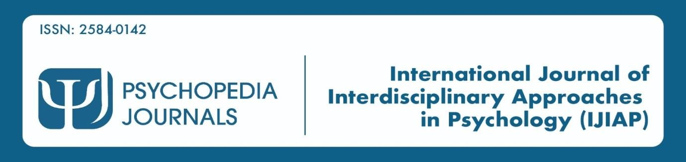

Assessing the combined impact of Negative Evaluation and Rumination Tendencies on Self Concealment Behaviors among Young Adults

Anishka Bhandari, Master’s in Arts, Clinical Psychology

anishka123go@gmail.com

Abstract

The transition from childhood and towards the adulthood is an important and critical period of our lives. It is characterized with an increase level of self-awareness, exploration of one’s personal identity, and the need to navigate through several complex interpersonal dynamics. During this developmental phase, every individual in this world encounters a certain number of negative evaluations from others at some point or the other. This can potentially trigger some amount of ruminative thought patterns accompanied by maladaptive coping mechanisms, one of them being referred to as self-concealment. Self-concealment is the intentional suppression of personal details from others which can impact an individual’s psychological well-being, social functioning, and overall adjustment. The current study aims to investigate the impact of both negative evaluation and ruminative tendencies on the self-concealment behaviors among young college going adults. Using the snowball sampling the data was collected. By giving insight on the complex synergism of these factors, this investigation will hold a unique potential to shed light on the evidence-based interventions and provide a good supporting strategy that

can facilitate an authentic self-expression, resilience, and a healthy interpersonal connection during this pivotal and nerve-wracking life stage.

Keywords: Self Concealment, Negative Evaluation, Rumination

INTRODUCTION

As a child goes through the developmental stages and moves towards adulthood, some very significant changes across multiple domains of his or her life happens. As young adults pave their way into the complexities of establishing a dynamic autonomy, forming mature interpersonal relationships, and solidifying their identities, they encounter numerous challenges. These challenges and hurdles make an individual build their psychological well- being and social functioning structure. One such of these challenges that has maintained its increasing attention in the research area, is the experience of negative evaluation, which can be the consequences because of various sources, these conflicts arise from academic settings, professional endeavors, and interpersonal interactions.
Fear of negative evaluation is one of the most significant factors that contributes to a person having social anxiety, it is also characterized by having an intense level of apprehension about others' evaluations and keep on distressing over potential negative judgments. Due to this, the fear can make individuals avoid various evaluative situations as much as they can and expect negative evaluations from others. According to several empirical studies, it has been explored that fear of negative evaluation plays a crucial role in the development of person having anxiety, negative thinking pattern, and maladaptive coping strategies to avoid it.
It is also considered as a trans-diagnostic risk factor for various psychological disorders, and this has furthermore related to heightened levels of distress, impaired problem-solving skills, and interpersonal difficulties. Furthermore, various emerging evidence are found which highly

suggests that rumination may contribute to factor towards the development of self-concealment behaviors, wherein the individuals intentionally withhold and suppresses personal information, thoughts, or feelings from others due to getting negatively evaluated.
Self-concealment behavior is a psychological term that refers to the tendency to suffer from actively hiding personal details from others, which is perceived as either intimate, negative, and/or distressing. If this sort of behavior continues to be severe, then it can significantly contribute to negative psychological health, including anxiety, depression, physical symptoms, negative self-esteem, loneliness, rumination, and social anxiety.
There have been various old studies which has individually explored these factors of negative evaluation, rumination, & self-concealment behavioral pattern, but many of them have not yet studied the impact of them being linked up all together. It has been noted that there seems to be a lack of empirical investigations that has not made a significant effect in examining the interplay between these psychological factors, in accordance with the order of limits related to the context of up-and-coming adulthood. This developmental phase provides us with a new and important convergence, as to how young adults keep up and manage with their ways to reach the complexities of establishing autonomy, forming mature interpersonal relationships, and making their own personality in this world with societal expectations.

Review of Literature

Busch et al. (2023) conducted a study on first-generation college going students, LGBTQ+ community students, and physically disabled students reported high levels of negative evaluation compared and reported that fear of negative assessment can cause them to overthink and ruminate their responses and show lack of participation in class.

Serpici and Dogan (2023) conducted a descriptive cross-sectional study which contained undergraduate nursing students (n = 283) and concluded that the fear of negative evaluation was detected. Additionally, it was found that there is no link with nursing students' perceptions of clinical decision-making.

Boschen (2023) conducted a study to investigate the impact of rumination on verbal and visual task performance. The study asserted that rumination may not significantly interfere and hinder within the individuals' cognitive performance.

Davis (2023) executed an empirical study in examining individuals who have the urge to always conceal unflattering information and have the tendency to surround themselves with negative affect due to conflicting drives and fear of consequences. The findings revealed that the people who self-conceal' over their insecurities and fear of the personal consequences of self-disclosure would hike up over the exhausting and debilitating cycle of suppression and compulsive actions that leaves them feeling anxious and guilty.

Khalid et al. (2023) explored in their study the mediating role of self-concealment and its interplay between Academic Perfectionism and Depression among college going students. The researchers found that the academic perfectionism is a significant predictor of self-concealment behavioral pattern and depressive symptoms.

Thomas et al. (2022) examined and observed the effects of fear of negative evaluation on the emotional/social loneliness in a sample of young adults (N=162) aged 18-25 years. The findings revealed a positive correlation between fear of negative evaluation and emotional/social loneliness. According to the study provided, it was further concluded that the

fear of negative evaluation can potentially be responsible for factors like social and emotional alienation.

Biju et al. (2022) collected a data sample from 118 emerging adults from the commerce field aged 18-25. The results found that there is a significant positive relationship between procrastination and perceived stress. Additionally, there is a significant positive relationship between procrastination and fear of negative evaluation. According to the study's findings, procrastination is strongly correlated with both felt stress and a fear of receiving a poor grade.

Akgul and Bozca (2022) conducted a study and examined the correlation between elite and finest female athletes' perspective upon gender equality along with their fear of negative evaluation. The researchers also aimed to investigate the significant connection amongst age, education level, plus awareness of gender concepts. It was revealed that there were significant correlations in between different dimensions of the questionnaire, such as the understanding that men are superior and portraying the fact that women are indeed dependent on men.

Owens et al. (2022) conducted a study to analyze the degree of rumination may potentially be a factor associated with dysregulation of prefrontal functions that support cognitive control. Furthermore, it was revealed that higher levels of ruminating tendencies were crucially associated coming with a fundamental increase intensity of frontal negative slow wave amplitude.

Kim et al. (2022) carried out research wherein the authors examined the interplay and the relationship of self-concealment, basic psychological needs, collectivism, and suicidality in a sample of adults in the United States. The results concluded that there was a dissatisfaction

with the relatedness need as the only factor that significantly connected with increased suicidality.

Zhang et al. (2022) aimed to study how self-concealment can have an impact on the perceived social support surrounded amongst the youth living alone in China, the study revealed that there is a significant correlation between self-concealment, perceived social support, psychological needs met through internet gratification, and social self-esteem

Hollander et al. (2022) completed a research project that analyzed how internalized homophobia can have mediating effect on the predictive relationship between self-concealment on depression symptoms in LGBTQ older adults. It was also suggested that cognitive restructuring related to these factors may improve depressive symptoms.

Yildiz (2022) in the research analyzed whether the self-differentiation can be related to self- concealment behavioral pattern and whether this type of relationship can be healed by leading it with self-compassion as well as intolerance of uncertainty.

Mehdi et al. (2020) did an analysis which further demonstrated Group Behavioral Activation's Effects on Depression, Anxiety, along with Rumination in Patients who are diagnosed with anxiety and depression. The data that emerged from the results was that the Group Behavioral Activation was considered as effective in reducing and circumscribing depression, anxiety, along with rumination in patients.

Ibrahim et al. (2018) conducted a study to examine whether ruminating thought process affects severity of depressive symptoms. The data was collected from 85 patients from Psychiatry

Department at Mansoura University Hospital. According to the conductions of the test, the result found that the depressive disorder significantly correlated with severe ruminative thoughts.

METHODOLOGY

Research Objectives

- To explore the role of ruminative tendencies on self-concealment behavior among college going students.
- To assess the influence of negative evaluation on self-concealment behavior among emerging adults.
- To investigate the potential combined effects of negative evaluation and ruminating tendencies on self-concealment behavior found amongst young adults.

Hypothesis

Young adults with high levels of negative evaluation and rumination tendencies are more likely to engage in self-concealment behaviors.

Variables
Dependent Variable: Self - Concealment Behaviors
Independent Variable: Ruminating Tendencies and Negative Evaluation

Sample and Its Selection

A sample of 76 of young adults of age group of 18-25 years was taken. The sample was selected randomly via an open questionnaire that was distributed to college students by giving their consent. This was carefully thought through to make the study more inclusive.

Selection steps of the Sample

- full-time college going student status

- age criteria must be between 18 and 25 years

- fluency in English. Exclusion criteria will include- non-degree seeking students

Sample technique: Simple random sampling

Procedure of data collection: The data was collected via online questionnaire using google forms.

Description of Tools

Demographic data sheet: The demographic details of the participants were collected via online questionnaire and consisted of questions like name, age, gender, and educational qualification.
  - Rumination Response Scale (RRS): The scale as developed by Susan Nolen- Hoeksema (1999). The reliability of the scale is 0.90 and validity 0.40.
  - Self-Concealment Scale (SCS): The scale as developed by Larson and Chastain (1990). The reliability of the scale is 0.90 and validity 0.40.
  - Brief Fear Negative Evaluation Scale (BFNE): The scale as developed by Leary (1983). The reliability of the scale is 0.90 and validity 0.70.

Data Analysis/ Statistical Analysis

Descriptive and inferential statistical tools will be used to analyze the scores using SPSS 27- version.

Rationale of The Study

The rationale of the study is to explores on how the impact of negative evaluation and rumination tendencies can have a drastic effect towards a factor like self-concealment behaviors in young adults. This needs to be studied because self-concealment behaviors can have a detrimental effect on individuals' mental health and quality of life. Moreover, we must focus on understanding the factors that also play a major part to self-concealment behaviors. This research will help us formulate some important interventions as well as make supportive strategies for individuals who have difficulty while facing with these tendencies. For example, in-case if it is discovered that negative evaluation and rumination tendencies are potential predictors of self-concealment behaviors, then interventions that immensely target all these issues could be produced to reduce self-concealment and promote healthier coping mechanisms. In addition to everything else, through analysis of the relationship between negative evaluation and rumination tendencies, this study can make a contributing factor towards our comprehensive understanding of how these factors interact and potentially reinforce each other in the development and maintenance of self-concealment behaviors.

Results and Interpretation

Regression Analysis: To examine the predictive compatibility amongst the independent variables (negative evaluation and rumination tendencies) and the dependent variable (self- concealment behaviors).

Table 1

Statistical display of Multiple Regression Analysis
0.318 is the value in the R-squared, this signifies that there is about 32% of the changeability in SCS shown by the influence of BFE and RRS. The adjusted R-squared value is denoted to

be of 0.300, which further indicates that the predictor variables are responsible for a substantially significant but also a moderate amount of the variation in SCS.
The standard error of the estimate is 6.69301, indicating that the predicted values of SCS are relatively accurate.
The R-squared change for BFE and Rumination is 0.318, the F change is 17.706, the df1 value is 2, and the df2 value is 76. Both BFE and RRS are being considered as an imperative predictor variable for SCS, they are responsible for the amount of approximately 32% of the discrepancy. The predictive strength of this table 1 is showcased as moderate, this is mostly evidenced by the help of an adjusted R-squared of 0.300. The values that are estimated for SCS are displayed to be fairly accurate. It is proven by the evidence of the standard error for the estimation, which is clearly 6.69301. Overall, the table 1 turns out to be a good foundation for having a good understanding of these interplay which consists of BFE, RRS, and SCS.

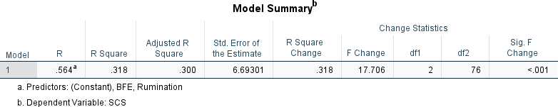

Table 2

Statistical insights by ANOVA

The BFE and RRS as predictors gives an understanding about the variation, they produced in the dependent variable SCS. It is seen in the Regression section.

The indication of the F-value being a 17.706 prominently suggests that the regression table is statistically significant at a p-value of .000, that closely indicates that the predictor variables collectively have a significant impact on the dependent variable.
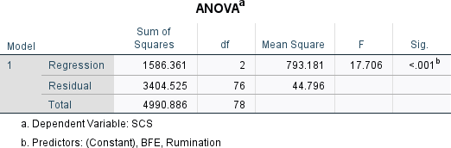

Table 3

The histogram indicates that the independent variables of rumination and negative evaluation are significant predictors of self-concealment behavior.
Mean: -4.02E-16, which is very close to zero. The mean refers to the average value of all the data points in the distribution.
Std. Deviation: 0.987. It's not a very high standard deviation, but it's not super low either. N: 79. This represents the total number of data points used to create the histogram.
The analysis of the data indicates that those people who exhibits tendencies of ruminating behavior and they also engage in a negatively evaluation of themselves (high RRS) are also more likely to engage in self-concealment behaviors (SCS). Additionally, it is given that there is a weaker positive association between self-concealment and positive emotional traits (BFE). The distribution of self-concealment scores (SCS) is centered around zero, with a slight dispersion on the positive values.

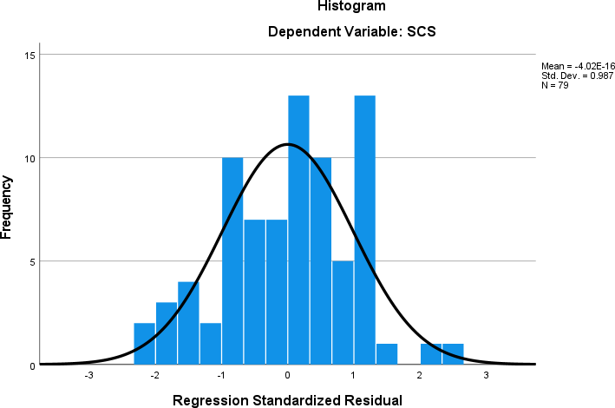

Table 4

There is a relatively random distribution seen of the residuals around the horizontal line at zero based on the scatterplot.
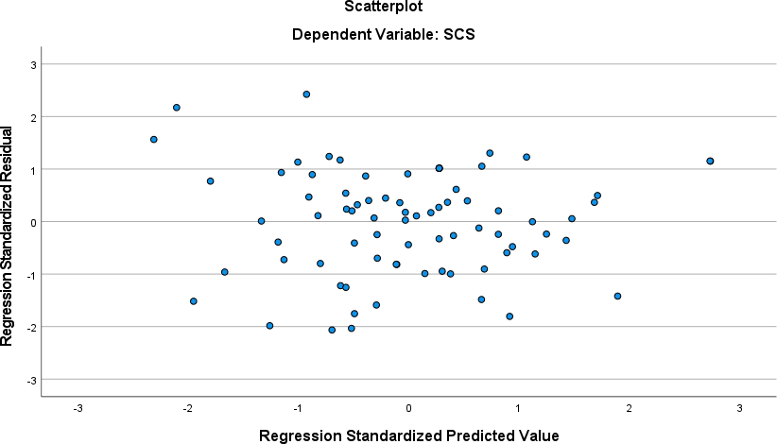

Table 5

The Pearson correlation coefficients between three variables: BFE, RRS, and SCS

Correlations
 |  | BFE | RRS | SCS
BFE | Pearson Correlation | 1 | .037 | .235*
 | Sig. (2-tailed) |  | .747 | .037
 | N | 79 | 79 | 79
RRS | Pearson Correlation | .037 | 1 | .520**
 | Sig. (2-tailed) | .747 |  | .000
 | N | 79 | 80 | 80
SCS | Pearson Correlation | .235* | .520** | 1
 | Sig. (2-tailed) | .037 | .000
 | N | 79 | 80 | 80
*. Correlation is significant at the 0.05 level (2-tailed).
**. Correlation is significant at the 0.01 level (2-tailed).

Table 6

Correlation coefficients showing the correlation between each pair of variables. Tendencies for rumination and negative assessments: These are related by a slight positive correlation, with a correlation coefficient of 0.320. According to this it is indicating that people who tend to focus constantly on negative thoughts are also prone to having a negative self- evaluation.

Rumination and Self-Concealment: 0.111 which reflects the correlation between these variables, according to this it is suggested that a very minute link is shown that is almost negligible.
Negative Appraisal and Concealing Oneself: The correlation coefficient of 0.211 indicates a slight positive correlation. Self-concealment behaviors produced and showcased by individuals tends to display low opinion of themselves, and they try to hide aspects of themselves from others.
The significance values (p-values) below each correlation coefficient are also displayed in the table. These values indicate the probability of the observed correlation happening by chance. A p-value lower than 0.05 signifies a noteworthy correlation, suggesting that the correlation observed is probably not due to chance.
Every correlation in this table shows statistical significance with p-values lower than 0.05. Nevertheless, it is essential to keep in mind that the correlations are not strong, indicating that the connections are relatively small.
In general, the table indicates potential weak positive connections between rumination, negative evaluation, and self-concealment behavior. Individuals who engage in self- concealment behaviors are slightly more prone to rumination and negative self-evaluations.

Test Statistics
 | BFE | RRS | SCS
Chi-Square | 52.785a | 30.500b | 35.500c
df | 28 | 33 | 27
Asymp. Sig. | .003 | .592 | .127

a. 29 cells (100.0%) have expected frequencies less than 5. The minimum expected cell frequency is 2.7.
b. 34 cells (100.0%) have expected frequencies less than 5. The minimum expected cell frequency is 2.4.
c. 28 cells (100.0%) have expected frequencies less than 5. The minimum expected cell frequency is 2.9.

Discussion
This study investigated the impact of negative evaluation and rumination tendencies on self- concealment behaviors in young adults. The findings offer a valuable insight into these factors and how they can potentially influence how this emerging generation manage their self- representation. These factors were analyzed by conducting three self-report scales. The data was collected via online questionnaire using google forms. Brief Negative Evaluation Scale was used to analyze individuals’ fear of getting negatively judged and perceive their worry and fear of criticized.
The Rumination Response Scale was used to measure individuals’ nonconstructive and negative pattern of persistent thinking. The third factor for the individuals were evaluated by the help of Self Concealment Scale.

Key Findings

Upon thorough investigation, it is seen that the results support the hypothesis that negative evaluation and ruminating tendencies will affect and will make significant changes with self- concealment behaviors.
After conducting a comprehensive regression analysis, the results revealed that the factors, negative evaluation (BFE) plus rumination (RRS) together give an explanation that there is a moderate proportion (32%) of the variance in self-concealment scores (SCS).
Correspondingly we also conducted the ANOVA test which also confirmed the statistical significance of these interplay of elements.
It was also examined that correlation coefficients further indicated a weak to moderate level of positive correlations between all these three variables.
The study also confirmed the fact that people who have higher negative evaluation proneness and ability to ruminate constantly were more likely to be prone to report higher self- concealment behaviors.
It was seen that there was a weak but positive correlation between negative evaluation and rumination inclination, providing a suggestion that these factors might co-occur.

Limitations and Future Directions

The study depends solely on the self-reported measures which is a limitation because it can cause social desirability bias and because of that it will also influence responses.
A major flaw of conducting a cross-sectional design means that it will surely limit the ability to establish and display causal relationships.
Future research and studies could help in utilizing many longitudinal designs to conduct and examine how factors like how getting exploited by negative criticism and adopting a pattern of

ruminating thinking will influence the development and establishment of self-concealment behaviors over time.
The study can be more influential when it will also exploring potential moderators, such as social anxiety or cultural background, this could provide a more comprehensive understanding of this relationship.
Investigating interventions that target and lookout for negative self-evaluation and ruminative thinking will help young adults to develop various healthier coping mechanisms and reduce the burden of self-concealment behaviors.

Conclusion

The purpose of the study was to find out how the impact of negative evaluation and ruminative thinking will be on self-concealment behavior amongst young adults. The results indicated that the participants who received high scores on the ‘’Brief Negative Evaluation Scale (BFE)’’ and “Rumination Response Scale (RRS),” also received potentially moderate to high scores on the “Self-Concealment Scale (SCS),” meaning it is seen that the results support the hypothesis that negative evaluation and ruminating tendencies will affect and will make significant changes with self-concealment behaviors. It was also confirmed the statistical significance of these interplay of elements.
The findings highlight the potential negative consequences of negative self-evaluation and rumination on self-concealment behaviors. By understanding these factors, we can develop strategies to facilitate the young and emerging adults build a healthy and a positive self-esteem, manage negative thoughts, and express themselves authentically.

REFERENCES

Carly, A, Busch., Nicholas, J., Wiesenthal., Tasneem, F, Mohammed., C., Kasper., E., C., Goodwin., Katelyn, M., Cooper. (2023). The Disproportionate Impact of Fear of Negative Evaluation on First-Generation College Students, LGBTQ+ Students, and Students with Disabilities in College Science Courses.. CBE- Life Sciences Education, doi: 10.1187/cbe.22-10-0195

Derya, Akça, Doğan., Ayşe, Serpici. (2023). Nursing Students' Fear of Negative Evaluation and Perceptions of Clinical Decision-Making.. Journal of Nursing Education, doi: 10.3928/01484834-20221011-02

Mark, Justin, Boschen. (2023). The Impact of Ruminative Thinking on Verbal and Visual Task Performance. doi: 10.59158/001c.73835

(2023). Relationship between Academic Perfectionism and Depression: Role of Self Concealment among Students. Pakistan journal of education, 39(2) doi: 10.30971/pje.v39i2.879

Alphy, Shahul., Sreedevi, Krishna, M., Sandra, Saji, Thomas., Vaseela, K, Thaha., Jikku, Mariam, John. (2022). Fear of Negative Evaluation and Emotional / Social Loneliness in Young Adults. International journal of engineering technology and management sciences, doi: 10.46647/ijetms.2022.v06i05.078

Aleena, Susan, Varughese., Ajeena, Achu, Biju., Aleena, Sarah, Varghese., Jithu, Shaji, Varghese., Krupa, Dinah, Mathews. (2022). Procrastination, Fear of Negative

Evaluation and Perceived Stress Among Emerging Adults. International journal of engineering technology and management sciences, 450-454. doi: 10.46647/ijetms.2022.v06i05.070

Aysel, Bozca., Mehmet, Akgül. (2022). Examination of the Relationship between Elite Female Athletes' Views on Gender Equality and their Fear of Negative Evaluation. Akdeniz Spor Bilimleri dergisi, doi: 10.38021/asbid.1150163

Max, Owens., Melissa, Cloutier., Ashly, Healy. (2022). Rumination reduces processing efficiency in visual working memory.. Journal of Vision, 22(14):4066-4066. doi: 10.1167/jov.22.14.4066

Mehdi, Zemestani., Iran, Davoudi., M, Mehrabizadeh, Honarmand., Yadollah, Zargar. (2020). Effectiveness of Group Behavioral Activation on Depression, Anxiety and Rumination in Patients with Depression and Anxiety. Journal of Clinical Psycology, 5(420):73-84.

Ingrid, Hogge., Jisu, Kim., Eunha, Kim. (2022). The Burden of Keeping Things to Yourself: Self-Concealment and Suicidality. Counselling Psychology Quarterly, 1-19. doi: 10.1080/09515070.2022.2150144

Banu, Yildiz. (2022). Self-differentiation and self-concealment: serial mediation by self- compassion and intolerance of uncertainty. The Educational and Developmental Psychologist, 40(2):190-200. doi: 10.1080/20590776.2022.2111210

Christopher, Calzada., Carl, St, Goar., Matthew, Hollander., Vennisia, Mo., Jamie, P, Kiefer., Benjamin, Hougaard., Nicole, Carre., Rowena, Gomez. (2022). Internalized homophobia mediating the relationship of self-concealment on depression in lgb older adults. Innovation in Aging, 6(Supplement_1):847-847. doi: 10.1093/geroni/igac059.3036

Linran, Zhang., Xiaoyue, Fan., Zhanyu, Yu. (2022). Living Alone but Not Feeling Lonely: The Effect of Self-Concealment on Perceived Social Support of Youth Living Alone in China. International Journal of Environmental Research and Public Health, 19(21):13805-13805. doi: 10.3390/ijerph192113805

